LOW BUDGET DIET PLAN
Morning:
- 50 g oats
- Peanut butter
- 1 Banana
- 2 egg
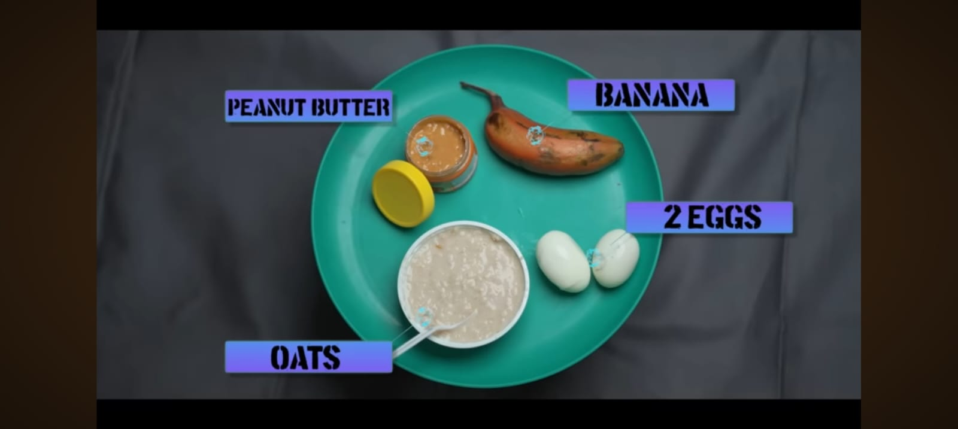
Snack:
- 4 wheat bread or normal bread
- Peanut butter
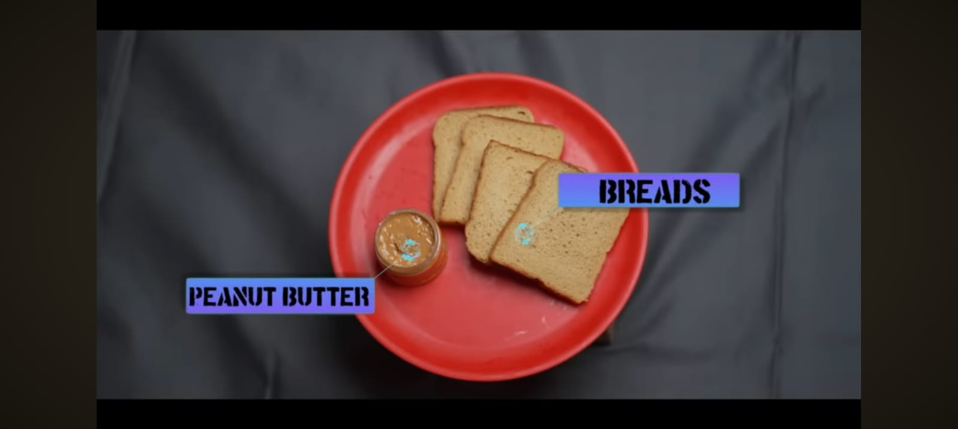
Lunch:
- 250g rice
- 250g dal or sambar
- 3 eggs
- Half cucumber
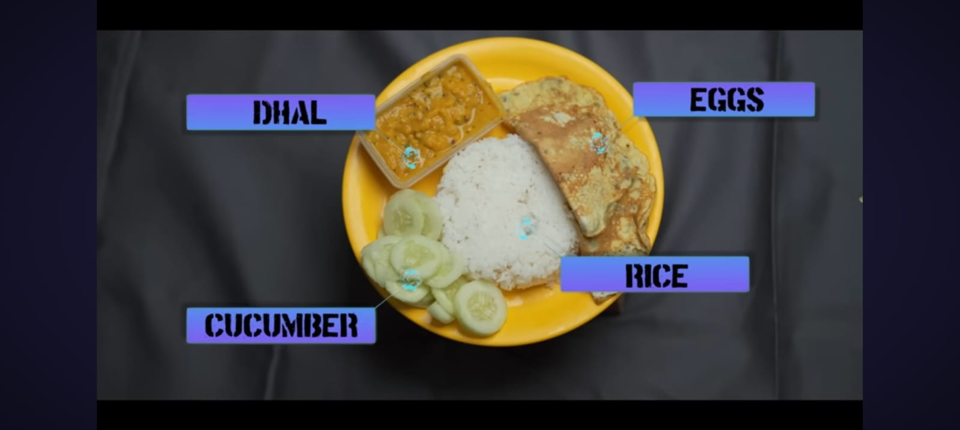
If you have exams, try to do workout and diet for any 3 days in a week.
Snacks:
- 250 ml milk
- 50g peanuts
- 200g boiled potato
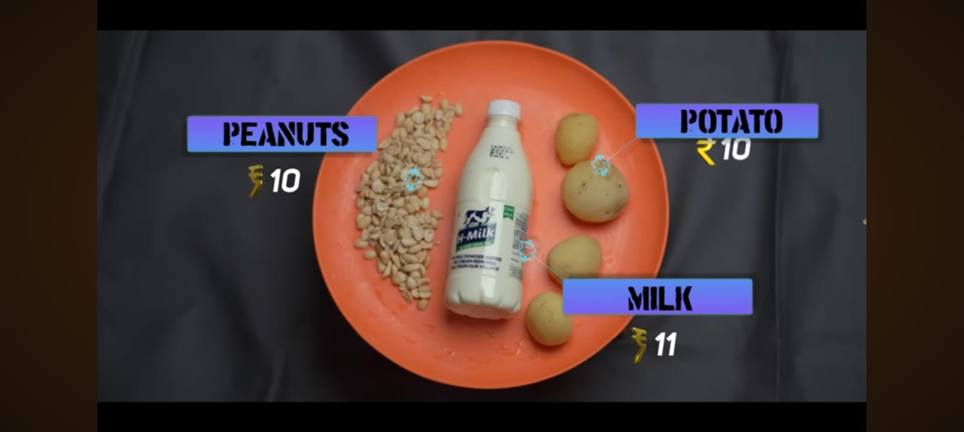
Dinner:
- 100g of boiled moong (ginger, garlic, green chilli, salt and mix it)
- Put 4 dosa from the above mixture with dal
